Areeba Code Challenge

**Release: 1**

# Code Challenge technical documentation

**Modification History**

|  |  |
| --- | --- |
| **Release** | **Comments** |
| Release 1 | Author: Majd Haidar  Date: 08/08/2021 |

# Application

This document describes the skills and knowledge used to create java application on a mobile device that can control a windows machine over a Bluetooth connection.

Build client/server application, the client will be the mobile device that will connect to windows machine through initialized Bluetooth service.

* Both endpoints must support Bluetooth and pair for the initialization of the connection.
* Client will be mobile device interacting with the machine running discoverable Bluetooth service.
* Server which exposes Bluetooth service for nearby mobile devices to connect and accept requests

## Client Side

Android Studio is used to build mobile java application (Client) where android java Bluetooth APIs are used in order to handle the following

* Enable Bluetooth on mobile
* Display list of paired Bluetooth devices
* Connect to machine running Bluetooth service
* Send instructions to the windows machine

Build the client interface in android studio using basic layouts components, keeping application user experience simple and easy. By running the application the user will be able to control mouse and keyboard of a windows machine.

Image below shows the view will be displayed incase device Bluetooth is not enabled.

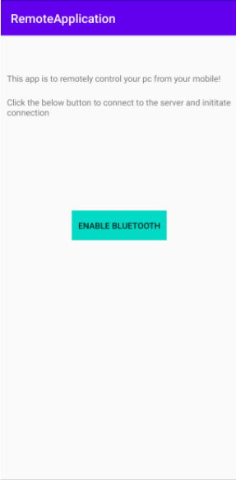

Image below demonstrate how list of paired devices are displayed. The user selects the windows machine that is running the server and waiting mobile device to connect.

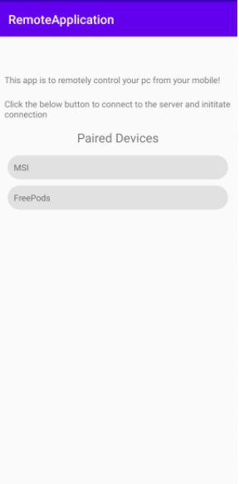

After connecting to windows machine, user can control both mouse and keyboard using the elements provided in the layout.

* Touch pad to move the mouse
* Keyboard drawer to display keyboard and start typing

## Server Side

Server web application is built using Spring boot web starter. This web application will allow user to initiate Bluetooth service listener which will get requests from the client (mobile application) and handle inputs from client to apply instructions on the windows machine.

The server will control and allow device to connect through Bluetooth manager which will make machine device accessible by nearby mobile devices.

Bluetooth packages used in the server side are

* javax.bluetooth
* javax.microedition

Package used to translate client inputs into visual machine actions

* java.awt

Images below demonstrate the web application view for starting Bluetooth server to handle client connection and actions.

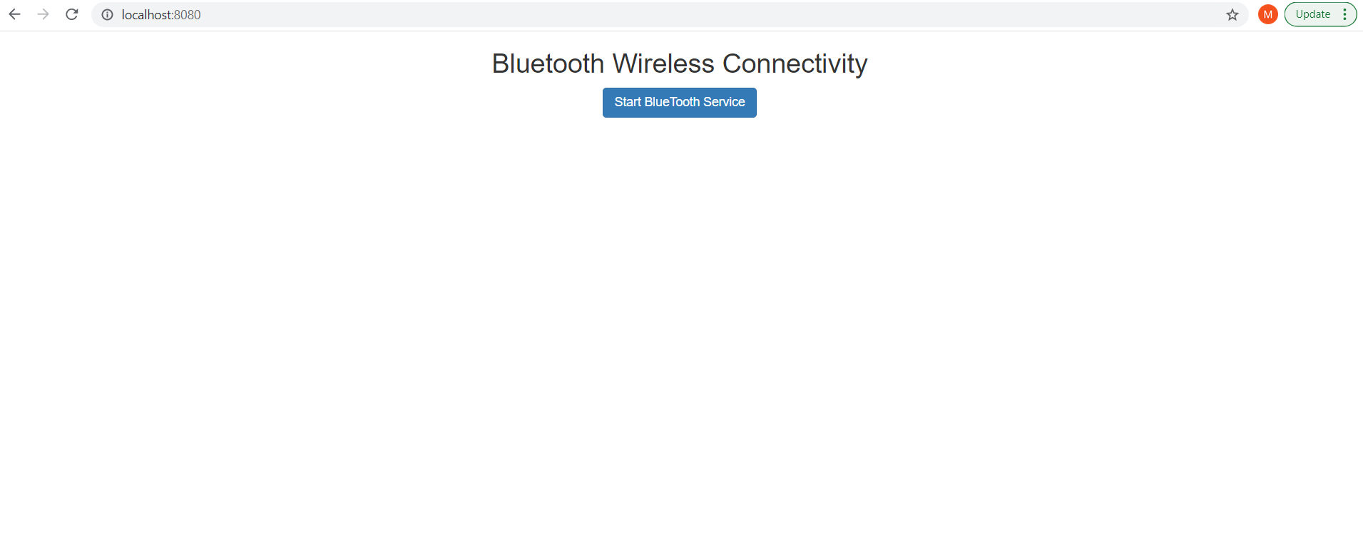

On press connect, Bluetooth manager will initialize Bluetooth service to be discovered by mobile app and success alert will be shown

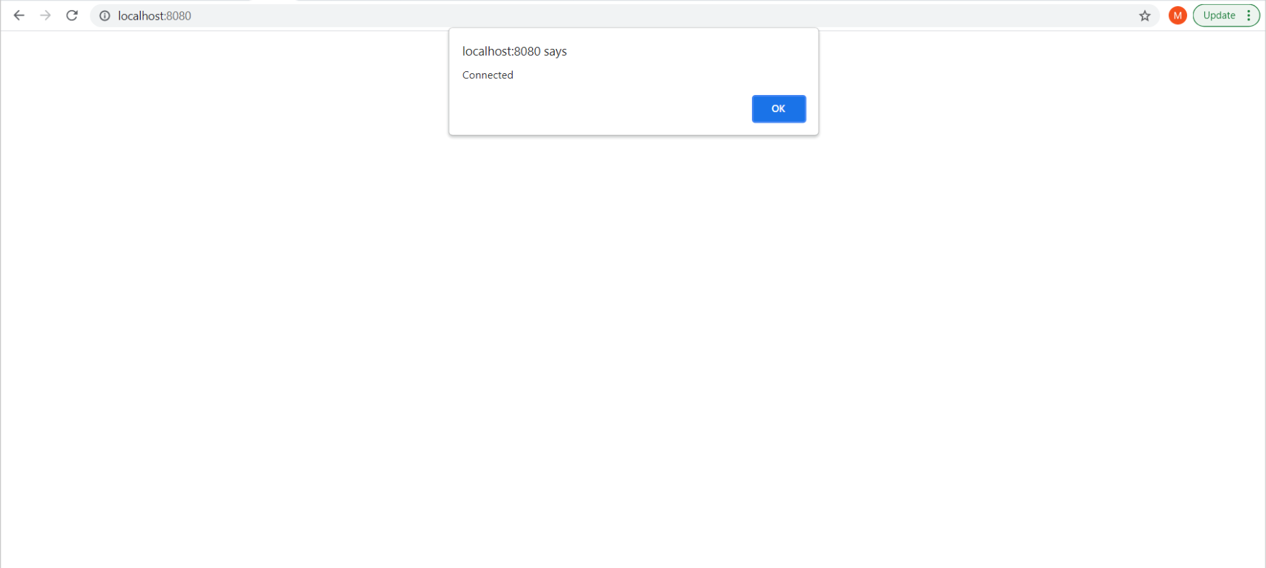

**Links and References**

* [Using the Java APIs for Bluetooth Wireless Technology, Part 1 - API Overview](https://www.oracle.com/technical-resources/articles/javame/bluetooth-wireless-technology-part1.html#discovery)
* [Using the Java APIs for Bluetooth, Part 2 - Putting the Core APIs to Work](https://www.oracle.com/technical-resources/articles/javame/bluetooth-wireless-technology-part2.html)
* [Developing Bluetooth-enabled apps with Java](https://icyrock.com/blog/2012/11/developing-bluetooth-enabled-apps-with-java/)
* [Working with Network Interfaces in Java](https://www.baeldung.com/java-network-interfaces)
* [BlueCove JSR-82 for J2SE implementation.](http://www.bluecove.org/bluecove/apidocs/overview-summary.html#DeviceDiscovery)
* [BLUETOOTH FRAMEWORK AND RFCOMM PROTOCOL](https://www.btframework.com/rfcomm.htm)
* [Mobile Android Java Windows](https://programmer.group/android-sends-mobile-photo-files-to-windows-pc-via-bluetooth-java-implementation.html)
* [Android APIs References](https://developer.android.com/reference/android/view/KeyEvent)
* [Android App Development in Java All-in-One Tutorial Series](https://youtu.be/tZvjSl9dswg)
* [Service Discovery Protocol](https://www.sciencedirect.com/topics/engineering/service-discovery-protocol)
* [Configure Android Studio](https://developer.android.com/studio/intro/studio-config?utm_source=android-studio#antivirus-impact)
* [android remote control for PC](https://codesmith.in/control-pc-from-android-app-using-java/)